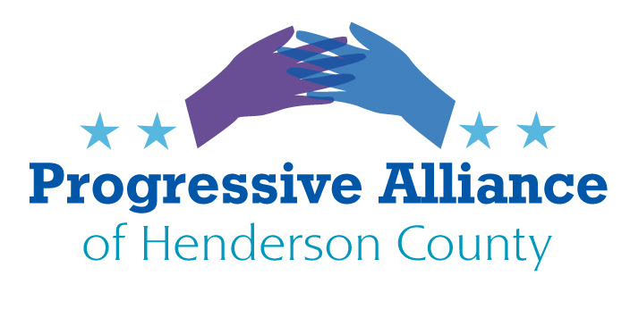

Postcard Party # 114 March 29, 2019

National

SUBPOENA THE MUELLER REPORT AND EVIDENCE

After 674 days, 34 indictments, and an untold number of cases handed over to district departments for continued investigation, Special Counsel Robert Mueller has submitted his report on Russia's interference in the 2016 election to Attorney General William Barr, officially ending the probe. The report has been described as “comprehensive” by Justice Department officials, and is assumed to be hundreds of pages long.

Within 2 days of receiving the report, Barr submitted a cryptic, carefully-worded 4-page letter to Congress providing his summary of the findings. Currently it is unclear if and when Barr will provide more information on Mueller’s findings.

Given the massive public interest, the many unanswered questions, and the significant importance to the country, the full report and evidence collected by Mueller should be given to Congress and made public.

Write to Senators Tillis and Burr to express concern about potential suppression of the findings of the Mueller investigation.

TRUMP CUTTING HALF BILLION DOLLARS FROM NC MILITARY INSTALLATIONS

In February, the Trump administration declared a national emergency which allows the administration to transfer money from the military budget to the construction of a wall along the southern border. Last week, the Department of Defense released a list of proposed cuts to military facilities all over the country. North Carolina military installations will receive half BILLION dollars in cuts -- the third-highest amount in the entire country after California and Florida. In total, North Carolina military facilities will be hit with $533 million in cuts.

Write to Senators Tillis and Burr and Congressman Meadows to share your thoughts on the loss of funds to our military and to North Carolina.

RAISE THE WAGE ACT

The federal minimum wage is has been stuck at $7.25 an hour and hasn’t received an increase in 10 years! HR 582, the Raise the Wage Act, was recently approved by the House Education and Labor Committee. Now it’s up to the House of Representatives to pass this critical legislation which raises the federal minimum wage to $15 an hour.

Raising the federal minimum wage to $15 an hour by 2024 would lift the wages of nearly 40 million working people―including 23 million women and 5 million single parents.

Write Congressman Meadow to express your feelings about HR 582.

State

NC HOUSE ADVANCES BILL FORCING SHERIFFS TO WORK WITH ICE

A North Carolina House judiciary panel approved legislation that requires sheriffs in all 100 counties to fulfill ICE detainer requests. The controversial House Bill 370 states that for anyone who is detained for any period of time under a criminal offense or an impaired driving charge, the person responsible for the facility must determine the prisoner’s residency status through questioning or through an examination of documents.

Immigration officials can ask to have criminal suspects held in county jails up to 48 hours on belief they are in the country unlawfully so agents have time to take them into custody. Under the bill, sheriffs who don't comply with detainers or other state immigration laws could face litigation by private citizens, with potential fines of up to $25,500 a day for repeat offenses.

Contact Representatives McGrady and Henson and Senator Edwards to share your thoughts on HB 370.

BILL TO RAISE THE MINIMUM WAGE IN NORTH CAROLINA

Recently introduced House Bill 366 proposes to raise the state’s minimum wage to $15 per hour over the next five years and index it to inflation thereafter.. A Senate companion bill will be introduced shortly.

Despite a decade of economic expansion and a boom in wealth at the top of the economic ladder, average wages in North Carolina have actually declined slightly. In 2018, the state’s median wage was down around $200 per year from where it was in 2009.

And while there’s no denying that higher wages are a cost for employers, the data also show that employers tend to reduce worker hours slightly rather than implement mass layoffs – a change in which workers still come out ahead. A 10-percent minimum wage increase will, for example, end up leading to a reduction in employee hours on the order of one or two percent.

Write Representatives McGrady and Henson and Senator Edwards to express your opinions on HB 366.

