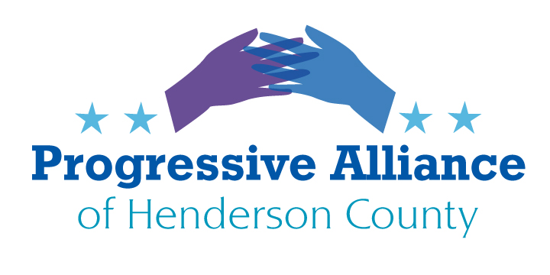
Post Card Party # 255 December 15, 2022
A NEW YEAR IS AROUND THE CORNER
This time we’re advising a break from writing postcards to public officials with requests for action. Yet please check out the next page to see a very positive postcard-writing suggestion. But we’re not suggesting that participants in the Progressive Alliance of Henderson County set down your pens (or close your Word programs) on the issues of our day. We’re asking you to try your hand at writing letters to the editor to greet the new year and to greet a bunch of far right Republicans just taking office.
To submit a letter to the editor, one typically has to go online to the Contact Us page of Hendersonville Times News, Hendersonville Lightning, Asheville Citizen Times, or Mountain Xpress. From a different angle, you can contact the relatively new Asheville Watchdog with suggestions about topics that its investigative journalists should explore.
In that spirit, here is a diverse set of suggested topics for letters to the editor, with very brief descriptions of the issues. Please note that the media outlets will almost universally only publish letters of two or three short paragraphs. Be sure of your sources when citing facts. Please note that your point can be made clearly and forcefully right from the start.
Now we wish everyone a happy, productive, and healthy New Year!
- Medicaid expansion: Prior to the November election the NC House and NC Senate passed separate bills to accept Medicaid expansion. Gov. Cooper was involved in negotiations with House and Senate leaders. (Both bills had provisions concerning other aspects of healthcare, which may be subject to compromise or continued controversy.) No movement has occurred in the post-election session, which will end soon. It is hard to say whether Medicaid expansion will be more difficult to achieve when the new General Assembly is seated in January 2023, with some changes in leadership. Public pressure continues to be necessary.
- Medicare For All / Single-Payer Healthcare: For the whole country, the adoption of Medicare For All (or some version of single-payer healthcare) continues to be the long-term objective. Public action to keep our eyes on the prize continues to be necessary.
- The illegitimate Supreme Court: The super-majority reactionary Supreme Court continues to issue tortured hyper-religious, far right rulings as though it is a Council Of Elders that is not accountable to anyone. Letters concerning any of the Court’s sectarian and repressive rulings or its ethical failures will be worthwhile.
- Anti-LBGTQ+ wannabe terrorists: North Carolina has witnessed an epidemic of Halloween-costumed, high-capacity weapon-toting demonstrators seeking to intimidate and terrorize the LBGTQ+ community and everyone who values human rights in America. Call out these vigilantes who seem to be so insecure about their “manhood” or “womanhood” that they try to silence anyone who values all people.
- Henderson County Public Schools: There is a risk that the increasingly reactionary Henderson County Board of Education will push further to defund public education in favor of sectarian and for-profit schools and will advocate for banning books they don’t like from being available in school libraries for all grades. This situation calls for progressive and sensible people to show up at all school board meetings. Letters to the editor about questionable behavior by the Board will also be helpful.
- Henderson County Draft 2045 Comprehensive Plan: This plan is still under discussion and may be a long way from adoption and implementation. Familiarize yourself with the plan and its progress https://www.hendersoncountync.gov/planning/page/county-comprehensive-plan, and then write a letter to the editor about parts (or all) of it that concern you.

YOU DIDN’T HAVE TO DO WHAT YOU DID BUT YOU DID AND WE THANK YOU
Immediately below you will find a list of the progressive candidates for office who campaigned on our shared values this fall. Unfortunately, none of these fine folks won, although progressives did win some very important races elsewhere in North Carolina and, as you know, progressive and upstanding candidates won throughout the USA. Please take a few minutes to send our progressive partners a postcard of appreciation. We look forward to working together with the people listed here in the years to come.

