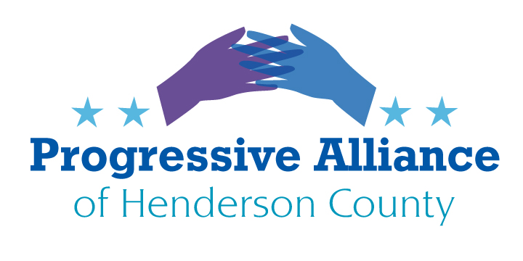
Post Card Party # 261 April 21, 2023
We celebrate the signing of Medicaid Expansion, under the Affordable Care Act, in North Carolina. Send thanks to Governor Cooper and the legislators who have consistently supported this for almost ten years. It still remains, however, the enact the necessary funds into the upcoming budget, so we need to keep the pressure on the NCGA.
WE ARE PARTNERING TODAY WITH JUST ECONOMICS, TO ADVANCE THEIR ESSENTIAL PRIORITIES FOR EVERYDAY WORKING PEOPLE IN NORTH CAROLINA (who often pay a greater percentage of their income in taxes than the top 10%, because regressive sales tax and various fees are often more significant than federal and state income tax for the bottom 20% to 50%). Key iasues to address with the NCGA are:
RAISE NORTH CAROLINA’S MINIMUM WAGE: NC’s current minimum wage is $7.25 per hour and has not been increased since 2018. Ideally, our state’s minimum wage should be raised to match a living wage (varying by county and whether a job includes benefits or not). A “living wage” is high enough for an individual to purchase the necessities of life. The low end of a North Carolina living wage is around $15 per hour or at least twice the current minimum wage, which is probably a good starting point for immediately raising the minimum wage, ideally to then rise over time with Cost Of Living Adjustments (COLA).
RAISE TEACHER PAY: Governor Cooper’s budget proposes to increase average teacher pay 18% over the next two years (based on length of tenure). The Republicans in the Senate and House have proposed a 10% increase for 2023 and another 6% increase for 2024 (again based on length of tenure). As of 2022 the NEA estimated that NC teacher pay ranked 34th in the nation. Governor Cooper’s proposal will bring us closer to parity with other similar states and it can address the current crisis of many teachers leaving the profession at the same moment that qualified and experienced teachers are in short supply.
DO NOT REPEAL NORTH CAROLINA’S CORPORATE INCOME TAX: Existing legislation will repeal the corporate income tax by 2030. Income taxes are progressive taxes, levied on corporations and individuals based on their income and ability to pay. Repealing the corporate income tax will achieve one illicit goal, by making it far more difficult for governments to serve the people. Repealing the corporate income will also require state and county governments to raise extremely regressive sales taxes in order to provide basic services. They may also raise property taxes, which have the regressive effect of raising the cost of housing for the poorest North Carolina residents.
JUST ECONOMICS has a list of Henderson County employers who pay a living wage and have pledged to continue to do so. Please send them a thank you postcard in appreciation of their participation in this essential campaign.
WE ARE ALSO PARTNERING TODAY WITH PISGAH LEGAL SERVICES, TO ADVANCE THEIR ESSENTIAL PRIORITIES FOR EVERYDAY WORKING PEOPLE IN NORTH CAROLINA. Key themes for your postcards to the NCGA and Sens. Budd & Tillis, as well as Rep. Edwards, include:
- The expanded Child Tax Credit had a major impact on children in North Carolina!
- Support Biden’s 2024 budget, which includes the permanent expansion of the Child Tax Credit and Earned Income Tax Credit.

These could be shortened to “Expand the Child Tax Credit and Earned Income Tax Credit” and “Access to tax credits benefits children in North Carolina”, if you prefer.
______________________________________________________________________
Despite their consistent failure to be responsive to all of their constituents, postcards to Sen. Moffitt, Rep. Balkcom, and Rep. Johnson are still warranted. It will be useful as well to contact Governor Cooper to ask him to support good legislation and push back against the Republican domination of North Carolina democracy. With that in mind, please see that Democracy NC urges support of three useful bills:
- Safeguard Fair Elections (H. 372, S. 313) will make it a crime to intimidate, threaten or engage in violence against election officials, and protect voters from coercion;
- Fix Our Democracy (H. 362, S. 306) will simplify voting with automatic voter registration while also removing big money from politics; and
- Freedom to Vote (H. 293, S. 226) will protect the right to vote, end partisan gerrymandering, combat election subversion, and ensure elections are fully funded.
- Reenact Child Tax Credit (H. 514, S. 390) will continue the state child tax credit, addressing the numerous details of any taxation legislation in order to reduce child poverty in North Carolina.

