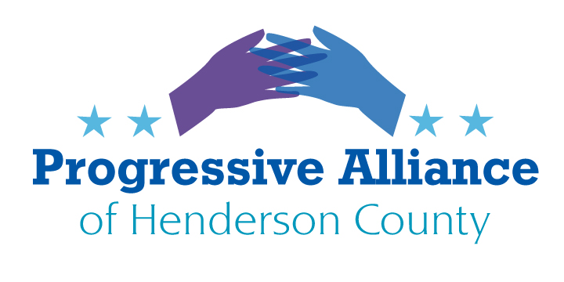
Virtual Post Card Party # 252 November 1, 2022
…WE INTERRUPT THIS PROGRAM…
You don’t need the Progressive Alliance of Henderson County to tell you the mid-term elections are next week on November 8. Getting out the vote is critical for progressive candidates and values to have any chance of victory in elections, legislatures, courts, and administrations. PAHC is not in the business of promoting one party and particular candidates. We wish, however, to draw your attention to the lively discussions on our Facebook page regarding candidates, policies, and the details of this year’s voting.
First: there is only one local contest for which there is more than one candidate in the race. That is for Henderson County Public Schools board of education. Three positions are to be filled. There are many posts supporting Mary Ellen Kustin and Dot Case; many posts surmising that all of the other candidates are actually in favor of dismantling public education and in favor of censoring LGBTQ+ content in classrooms and school (and probably public) libraries; and many posts urging people to vote for only the two aforementioned candidates, to not give a boost to any of the others.
Second: these are the contested offices at the NC and national levels for which there are Republican and Democratic candidates as well as the occasional Libertarian or Green. Per Facebook posts on PAHC’s page, there is only one progressive candidate in each of these races. There is also only one candidate in each of these races who has spoken about policies rather than exploiting fear and anxiety exclusively.
NC House District 117
NC Senate District 48
NC Supreme Court Associate Justice Seat 03
NC Supreme Court Associate Justice Seat 05
NC Court of Appeals Judge Seat 08
NC Court of Appeals Judge Seat 09
NC Court of Appeals Judge Seat 10
NC Court of Appeals Judge Seat 11
US House of Representatives District 11 (replacing MadCawthorn)
US Senate (replacing Richard Burr)
…WE NOW RETURN YOU TO YOUR PREVIOUSLY SCHEDULED PROGRAMMING…
On November 8 the mid-term elections will be completed, pending late returns, mail-in ballots, and so on. Our tasks are not simply to wait for the results and passively trust that the newly elected officials will act in the best interest of the entire Henderson County community. The issues that galvanize our individual and collective activism will remain. What to do next? Do what we did before, only better, more creatively, more in coalition with other groups and individuals who share our concerns and values. And, let us admit, do fewer actions that may not be particularly effective, focused, and, as time goes on, perhaps not as relevant as they once were.
WRITE: letters to the editor.
WRITE: postcards to lawmakers, executive government, other public officials.
WRITE: emails to lawmakers, executive government, other public officials.
RALLY: let the public know what matters.
VIGIL: let the public know what matters.
PAY ATTENTION: to facts; to arguments that challenge us to think; to arguments that challenge the balance of our emotions, values, and ethical senses; to our neighbors, friends, co-workers, and the complex intersectionality of our communities.
WORK AT THE LOCAL AND STATE LEVELS: Medicaid expansion; supporting public education (including implementing the Leandro decision); fighting censorship in schools and libraries; protecting reproductive rights; welcoming women from other states who seek abortions and reproductive healthcare in North Carolina; reducing dependence on fossil fuels; assuring implementation (with adequate tax dollars and regulations) of the high ideals and intersectionality of the draft Henderson County 2045 Comprehensive Plan. This list is certainly incomplete.
Write a postcard to a public official this week concerning one of these issues, or another one close to your heart.
WORK AT THE FEDERAL LEVEL: single-payer health insurance; supporting public education; fighting censorship and institutionalized discrimination against LGBTQ+ people; protecting reproductive rights; taking urgent and comprehensive action to address the global climate crisis; totally reforming our immigration system to create paths to citizenship for the millions on whom our current and long-term economic health depends, treating refugees and asylum-seekers in accordance with our existing laws and international law, passing DACA in Congress now, and managing our borders both humanely and effectively. This list is certainly incomplete.
Write a postcard to a public official this week concerning one of these issues, or another one close to your heart.

